Article submitted for consideration in the 2021 Annual meeting of the Population Association of America.

Author: Octavio Nicolas Bramajo

**Spatial inequalities of late-life depression prevalence: analysis of six European countries with a cohort based APC model.**

**Abstract:**

Late-life depression is increasing as a public health issue, but its prevalence varies across countries for a variety of reasons. There are reasons to think that such process is not only related with aging process of individuals, but also driven by cohorts. Using the Survey of Health and Ageing and Retirement of Europe (SHARE), we described Age, Period and Cohort (APC) trajectories of depression prevalence in adults aged 50 and above, using the EURO-D psychiatric scale. We compared six European countries during the 2004-2016 period: Denmark, Sweden, Germany, Italy, Spain and France.

By applying a detrended APC statistical model with a cohort-major parameterization to visualize linear and non-linear effects, we found that most countries follow up a J-shaped curve when describing the longitudinal age trajectory of late-life depression, along with strong cohort trends in Spain and Germany. While we could not find an increase of overall prevalence in the analyzed period for all countries, it still remains a public health concern due to continuous population aging.

**Keywords:** Depression, Aging, Cohort Studies, Descriptive Epidemiology, Social Epidemiology.

Motivation:

Depression is currently the second leading cause of years lived with disability worldwide (Ferrari et al., 2013) and it is expected to become the primary cause of disability around 2030, according to the WHO projections (2008). Thus, it is not surprising that depression, a non-fatal disease, is gaining attention as a population health issue among researchers. In particular, late-life depression is an important public health problem due to its association with multiple negative health outcomes, including mortality (Blazer, 2005; Fiske, Weatherell and Gatz, 2009, Horackova et al., 2019, Zhao et al., 2012) and also overall poor quality of life in the affected individuals and their partners and relatives as well (Pascual-Sáez et al, 2019). Understanding and analyzing late life health outcomes is becoming critically important, especially in the context of population aging, which is arguably the most important single demographic phenomenon in 21st Century. Addressing population health in the later stages of life is critical for a better understanding of how social security, health care provisions, pension systems and other aspects of social policy work and perform given this information.

Depression in adults and old-age adults can manifest in a variety of feelings and mood disorders. Sometimes it is the continuation of a disease recurrent along the previous life-course, but it can also be a new onset condition, or a side effect of another illness and/or medication treatments (Aziz and Steffens, 2013). Furthermore, since it is harder to notice, it is harder to measure it appropriately (Gennaro et al., 2019).

There may be several events in the life course that trigger depression, and such outcomes may be uniquely related to the particular experiences and expositions of individuals (Colman and Ataullahjan, 2010). Sometimes a group of individuals that share together a common characteristic (being the year of birth the most common example) are exposed singularly to a series of events during their life course, and such exposures may or may not affect them in different ways. This is a fundamental assumption in the concept of cohort for social analysis (Ryder, 1965; Glenn, 2005).

There is evidence that depression prevalence tends to increase in the oldest ages (Aziz and Steffens, 2013; Bell, 2014; Dewey and Prince, 2005), but less is known about how the age trajectory of depression has changed across cohorts and across time. Unfortunately, mainly due to data limitations, most studies describing depression prevalence by age restrict themselves to a single period observation and do not perform any kind of follow up to the population they study (either from a cross-sectional or longitudinal perspective). In other words, aspects of late-life depression and aging across countries over have been less studied in Europe, particularly from a cohort point of view. It is unknown what happened with depression prevalence rates across different countries over the last years. It is also unclear if the events that occurred during the last years (being the economic crisis that begun in 2008 the most significant from a societal point of view) actually had an impact in such trends. Periods of abrupt financial problems and other kinds of turmoil may spike negative health outcomes in mental health of the affected populations (Frasquilho et al., 2016; Riumallo-Herl et al., 2014; Thomson, Niedzwiedz and Katikireddi, 2018). This is not a minor point, considering that inequalities in health are socially based (Marmot, 2005) and mental health is not the exception (Fryers et al., 2003). It has to be noted that not all inequalities in mental health are a result of a specific event, but are strongly associated with other structural factors. Socio-economic status, living standards, social interactions, marriage status and other dynamic aspects influence mental health outcomes (Bell, 2014; Fryers et al., 2003). Furthermore, not all individuals of a given group are evenly likely to be affected by a particular event and mental health and late-life depression is an exemplary case of a phenomenon that affects more females than their male counterparts, with a clear gender gap across sexes (Blazer, 2005; Aziz and Steffens, 2013, Bell and Jones, 2015). Furthermore, late-life depression prevalence varies greatly across countries. In Europe, for instance, there is a clear gap in prevalence between the Scandinavian Countries, with lower prevalence rates, and the South/Mediterranean countries, which present significantly higher rates (Dewey and Prince, 2005, Van de Velde, Bracke and Levecque, 2010, Aichberger et al., 2010, Horackova et al., 2019). The reasons why there are spatial inequalities in depression prevalence are not clear, at a national trend, but previous evidence may suggest that socioeconomic and cultural factors may reinforce the spatial dimension of inequalities in prevalence (Cuadros et al., 2019)

Analyzing trends over different periods in late-life depression and differentials across countries by age and sex (and which factors are behind those trends and differences) is critical to have a better understanding of this health condition. Researchers, on occasion, decompose such trends over time into three types of effects: age effects, period effects and cohort effects. Age is arguably the most known of the three, and it refers to the effects that are a result of the unavoidable aging process of individuals in a certain population. The secular trends on a given phenomenon that occur across all age groups in a particular moment are conventionally known as period effects (Keyes et al., 2014).

However, some scholars (Spiers et al., 2011; Bell, 2014) argue that there is no sustained basis to think that changes over time in mental health and depression are due to continuous period trends (this does not imply that they do not exist at all), but to changes across different cohorts. Those cohort effects are related to changes across groups of individuals who share a certain characteristic (usually, individuals that come from the same birth cohort) which experience together (from a chronological point of view) certain events in the life course and their outcomes (Ryder, 1965; Hobcraft, Menken and Preston, 1982; Yang and Land, 2013). Such approach can lead to many interesting questions (that exceed the purposes of this study), such as: If depression is indeed growing as a health problem, what cohorts are driving this trend? Does that imply that it would affect younger cohorts over time as well? Or alternatively, since people are living more and more years, is the bulk of depression prevalence carried by the older cohorts? Do different countries share similar prevalence patterns across cohorts? Do the age effects by sex behave in a similar fashion in countries with different prevalence rates? What do these effects imply for health care, social policies or pension systems?

Approaches that try to decompose age, period and cohort effects separately are known as Age-Period-Cohort (APC) models (Holford, 1992; Yang and Land, 2013; Keyes et al., 2014; Acosta and Van Raalte, 2019). As mentioned, Age effects refer to the results of own aging process of individuals, Period effects highlight the influence of contextual factors that are related to a specific year of measurement, and Cohort effects are results of similarities of individuals that were born in a similar period, and have shared a common set of historical experiences, characteristics and circumstances across their life course. APC models are gaining traction in disciplines like Demography, Sociology and Epidemiology among others to analyze mortality and prevalence rates of a given phenomenon, but also things as varied as fertility changes, labor market analysis and residential patterns. This is possible due to improvements in computing power, a greater interest in analyzing cohort trends over time and several methods to deal with the limitations and difficulties inherent to APC analysis.

Previous findings:

There is a fair share of studies that focus on cross-national differentials in late-life depression in European countries (Dewey and Prince, 2005, Hansen, Slagsvold and Veenstra, 2017, Aichberger et al., 2010). Lower prevalence rates were found in Scandinavian countries, as Sweden and Denmark, while opposite results were found in Southern Europe, especially in countries like Spain or Italy (Dewey and Prince, 2005; Van de Velde, Bracke and Levecque, 2010; Aichberger et al., 2010; Horackova et al. 2019). Not only the overall late-life depression prevalence was higher in the latter countries, but it was notably higher in the oldest ages and affected mostly the females in such countries, while differentials in Northern countries were modest across sexes and different ages (Dewey and Prince, 2005; Van de Velde et al., 2010, Aichberger et al., 2010).

On the other hand, studies that address depression prevalence (or similar aspects) from an APC perspective are scarce and most of them do not involve European countries (Keyes et al., 2014, Wickramaratne et al., 1989, Lavori et al., 1987). However, we can reference the work of Bell (2014) as a watermark for the purposes of the study, by analyzing the mental well-being across a group of cohorts in the UK using an APC approach. The author finds that mental health trajectories have a curve trajectory in the late-life, with a steep increase in the last years of life and a relative deterioration of the mental well-being of the younger cohorts. In addition, he found that gender and marriage were strongly related with mental health, affecting life-course and cohort trajectories, with females and non-married individuals presenting worse mental health. Spiers et al. (2011), on the other hand, found no increases in mental disorder prevalence across English cohorts.

Thus, this is an interesting opportunity for providing a new perspective on the topic, while elucidating if any potential changes to depression prevalence rates over the last years could be related to age, period or cohort effects in selected aging populations in Northern and Southern Europe, given the previously mentioned prevalence gap across them.

Research objective:

This study intends to describe trends in the prevalence of depression by sex and age in selected European countries during the 2004-2016 periods applying “detrended”-APC models (Yang and Land, 2013, Carstensen 2007), using a cohort-based parameterization. The main objective is to visualize and distinguish age, period and cohort effects in depression prevalence for such countries.

**Data and Methods**:

Data source and definitions:

The main data source for this study is the Survey of Health, Ageing and Retirement in Europe (SHARE). SHARE is a multiple wave panel study that follows cohorts of non-institutionalized respondents aged 50 and over in several European countries from 2004 onwards. Successive waves were collected in 2007, 2011, 2013, 2015 and 2017 (and one special retrospective survey, also known as SHARELIFE, in 2009). The first wave started collecting data from twelve countries: Germany, the Netherlands, Switzerland, Austria, Sweden, Denmark, Spain, France, Italy, Belgium, Greece and Israel. During the following waves, more countries were added into the survey, more than doubling the initial group. Every wave is considered to be representative of the population of the surveyed countries (Bergmann et al, 2019). The survey provides information about physical and mental health of the respondents (at a household and individual level), among other detailed aspects of their sociodemographic characteristics (educational attainment, wealth, social support among others) and overall well-being.

Dependent variable and other key variables:

Depression is the main dependent variable of this study. The main attractive that SHARE offers for this project is the ability to compare the depression prevalence (we will use the notions of rates or proportions interchangeably in this article, although is the second one that is technically correct since prevalence is a proportion by definition) of different populations across multiple observations while using the same instrument.

SHARE utilizes the 12 item EURO-D scale measure, which has been validated in other studies of depression prevalence (Prince et al. 1999A, Prince et al. 1999B, Guerra et al., 2015). And we will follow the criterion established by Dewey and Prince (2005) to define clinically significant depression, also discussed and validated with the aforementioned previous studies: if the EURO-D score result is 4 or higher (from a scale of twelve non-weighted items, ranging from 0 to 12), it means that the respondent “would be likely to be diagnosed as suffering from a depressive disorder, for which therapeutic intervention would be indicated” (p.109). Late life depression, thus, would consider individuals aged 50 years and above that report scores equal or higher than the defined threshold value.

We intend to describe depression prevalence based on sex. We also explored partnership status and educational attainment as potential key variables, but due to some limitations in the sample size (particularly with wave 7) we decided to exclude the results from the final analysis.

Country selection and treatment of the data:

The relatively small sample size forces some assumptions and decisions regarding the composition of population in terms of age and cohort (and the countries deemed as suitable for trend analysis). There are seven SHARE waves that were collected during the 2004-17 period. However, SHARELIFE (wave 3) questions were recorded for the 2008-09 period but do not involve reports on depression prevalence.

After some testing, and considering the a priori unequal period timespans of the collected waves, we found a four age group distribution suitable for the purposes of this study. The range of those nine four-age groups varies from 50-53 (being 52 the mean year for that group) to 82 and over as the last open group. In order to make intervals suitable for APC analysis, we opted to merge waves 4 and 5 into its midpoint (2012), and the same for waves 6 and 7 (2016), which is particularly helpful given the scarcity of data in wave 7. Furthermore, we made an, admittedly, strong assumption: prevalence rates for year 2007 (corresponding to Wave 2) are the same to 2008 in order to make 4 years with equal intervals: 2004, 2008, 2012, 2016 (and consider removing cases present in both waves to avoid duplication of effects). However, if depression is a phenomenon driven by cohorts, this assumption may be more justifiable.

Accordingly, the selected cohorts encompass those born between 1920 and 1964. We will consider only valid cases that offer a response to the depression scale in the survey. Only a very small set of countries participated in all of the SHARE survey waves, limiting the potential for follow-up collection across countries to measure depression prevalence. Thus, we decided to choose six countries in order to see how APC effects behave across them. Three of those countries presented low prevalence rates by age in the first wave (Denmark, Sweden and Germany), and the remaining three presented high prevalence rates in that same wave (Italy, Spain and France).

We will use the cross-wave weights provided by SHARE in order to produce adequate estimations representative at population level (recreating “pseudo”-cohorts). After merging the aforementioned waves, it is possible to establish reasonable depression prevalence rates at a population level for age groups in all analyzed periods.

Thus, we end up with an overall of 432 age-period interactions as a result of nine age groups, six countries and four periods, separately by sex. Given the particular coding input necessary for the chosen APC strategy, there is no need to previously adjust or smooth exposures and counts.

Analytical strategy:

The approach for analysis involves, in first place, an exploratory phase involving the visualization of the standardized depression prevalence-rates across the selected European countries (using the total respondent population surveyed in the baseline 2004 wave as a standard) in the 2004-16 period.

Such rates are visualized with the standard four plots indicated by Carstensen (2007): Age by Period, Age by Cohort, Period by Age and Cohort by Age plots. This is done to visualize how the three dimensions of age, period and cohort interact across countries for different survey waves. All of those figures will be provided with assistance of the ggplot2 package developed for the open code R software (Wickham, 2016).

APC statistical models have the potential to identify trends over the three dimensions of age, period (in years) and cohorts (year of birth, usually). It is known that such approach comes with some limitations, particularly the linear identification problem that involves the impossibility of separating the Age, Period and Cohort effects from a mathematical point of view (Holford, 1992; Acosta and Van Raalte, 2019; Bell, 2014; Carstensen, 2007; Nielsen and Nielsen, 2014; Yang and Land, 2013). Such impossibility is based on the perfect collinearity of the three elements, due to the fact that mathematically A=P-C. As a result, a series of possible approaches to deal with the linear identification problem have been developed. An overview of some of the most commonly used statistical methods is provided in Yang and Land (2013) and comments about alternative graphical methods can be found in Acosta and van Raalte (2019).

In this case, we will take advantage of the approach that was suggested by Carstensen (2007), by using natural cubic splines to visualize the Age, Period and Cohort effects. In such approach, the dimensions of age, period and cohort are treated as continuous variables that follow a Poisson distribution (and as a result, are expressed in log values), that are graphically expressed in linear and non linear (2nd order) effects.

In this visualizations, there is one dimension expressed in terms of log rates (conventionally it is age, because it usually tends to be the strongest dimension to explain variation of a cer1tain phenomenon). The second dimension, in this case cohort, carries both the non-linear log-relative risk to an arbitrary reference cohort (whose value is constrained to be 0) and the log-linear trend (also known as drift) as well. The third dimension, in this case period, is expressed as the interaction of the remaining two, in rate-ratio residuals, and is constrained to have 0 slope on average and the function average is equal to 0 as well.

The APC effects are treated as non-linear functions of f(a), h(c), and g(p), along with the mentioned linear drift. In this case, the log-linear APC model for depression prevalence d at age a in period p for individuals with birth cohort c=p-a could be expressed as:

ln(*d*(*a*, *p*)) = *rco*(*a*) + *δ*(*c* - *c*0) + *g*(*p*) + *h*(*c*)

Where *rco(a)* are the age-specific prevalence rates in the reference cohort *c0*=1943 (chosen as a mid-point of the cohorts); δ represents the slope of the drift; *h(c)* is the cohort function, that can be interpretable as the log relative risk to cohort of reference *c0*, and *g(p)* is the remaining period function.

The “*Epi”* package was developed in R software (Carstensen et al., 2019) to, analyze APC trends (among many other possible uses) and we will use it to visualize the effects of each separate dimension of Age, Cohort and Period for the selected countries. The Carstensen natural splines approach provides the researcher an easy interpretation of the different separate effects of age, period and cohort in a simple fashion.

It has to be mentioned that since the available data for this study was not presented in equal age and period timespans (if we opted to use waves 1 to 7 separately), there is no linear dependency in principle. Thus, a straightforward factor model for each of the three dimensions could work and provide a solution, but the results in such a model would be biased, and most importantly, the source of bias would be unknown, which is obviously problematic. While the detrended cubic splines solution and the chosen analytical strategy for the data brings the linear dependency issue back into question (because it considers all the three dimensions as continuous variables), it also allows the researcher to have more control and knowledge of the potential results of the analysis. Furthermore, as mentioned by Acosta and van Raalte (2019), the Detrended-APC model allows the researcher to easily compare effects across different populations, as such is the case, and it also works well with relative sparse data (Dobson et al., 2020)

These particular models that can easily alternate between a cohort major and a period major parameterization (in other words, which dimension carries the drift) have a great deal of flexibility. However, the choice of parameterization is critical for modeling the effects of age, period and cohort, as results will be influenced by the constraints (based on either theoretical assumptions or external information) made by the researcher.

When analyzing mental health trends, it is accepted that we can make strong assumptions with theoretical foundation (Spiers et al., 2011, Bell & Jones, 2013, Bell, 2014). Those assumptions indicate that is unlikely that we can expect a continuous period trend affecting all age groups, apart from some specific valleys or peaks in certain contexts (like the last European recession). Thus, changes in mental health and depression that could happen over time are more likely to be explained by cohort effects, manifested in the collective experience of a set of individuals during their life course (Bell, 2014). As a result, the chosen model parameterization in this case is considered cohort based (also known as cohort major), using the 1942 cohort as a reference (since in this model cohorts are expressed as continuous variables we can use the hypothetical 1942 cohort as a reference instead of 1940 or 1944) and stripping the period dimension from its linear trend. Final technical details about the analysis indicate that we have chosen the naïve weights for the inner product in matrix multiplication for extracting the drift, and three knots (because the standard value, five knots, would probably result in overfitting given the scarcity of data) for fitting the cubic splines. Finally, while the natural splines solution does not “solve” the linear dependency problem (and neither it claims to), we can acknowledge that any potential bias provided is the result of the chosen parameterization that, in this case, is driven by theory and the assumptions made by the researchers.

Results:

Age- Standardized Rates:

Figure 1 shows Age-Standardized Prevalence Rates (or Proportions) of depression prevalence in the selected countries for population aged 50 and above during the 2004-16 period. As expected, prevalence rates are higher in Italy, Spain and France and lower in Denmark, Sweden and Germany. In some countries depression prevalence rates remained relatively stable and any variations in prevalence, most of them trending down, could be considered as moderate. This is not unexpected, given that we are considering that most changes in depression could be cohort based. However, there is a situation that catches the eye: Spain strong sustained improvement over the measured period (and to some extent, Italy and Sweden show some improvement as well), while Germany shows an increase of depression prevalence, and, to a lesser extent, so does France.

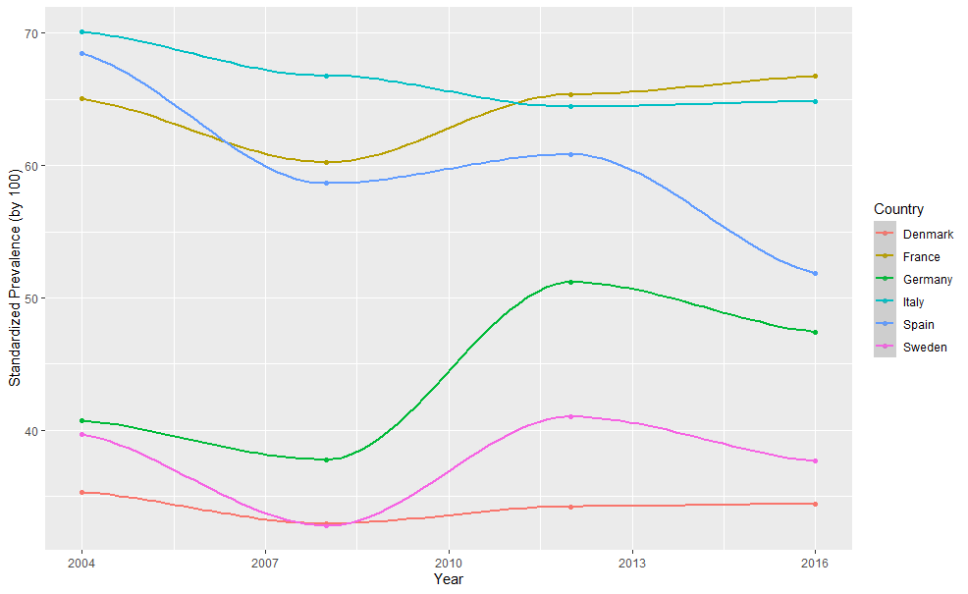

Figure 1. Age-Standardized Depression Prevalence rates by Country

(**author´s calculations based on SHARE-ERIC**).

Four Classical Plots: Age by Period, Period by Age, Age by Cohort and Cohort by Age.

In APC analysis, four exploratory plots are presented as an exploratory measure: depression prevalence by age for different periods (Figure 2), depression prevalence by period for different age groups (Figure 3), depression prevalence by age for different birth cohorts (Figure 4) and prevalence by cohort for different age groups (Figure 5). If the first two figures show parallel curves, this supports the presence of period effects (and an age-period model should be suitable as a result), and if the remaining plots show parallel curves, it implies that cohort effects are present (Carstensen, 2007).

Results present in figures 2 to 5 indicate that countries present very different patterns in each of those four two-dimensional plots. The figures indicate that the presence of some parallel lines could suggest some linear effects (which in this case we attribute to the cohort dimension). But also, there is a variety of non-linear effects (particularly with younger cohorts) present based on the change of slope across categories for the three dimensions of age, period and cohort, which supports the notion of an APC framework.

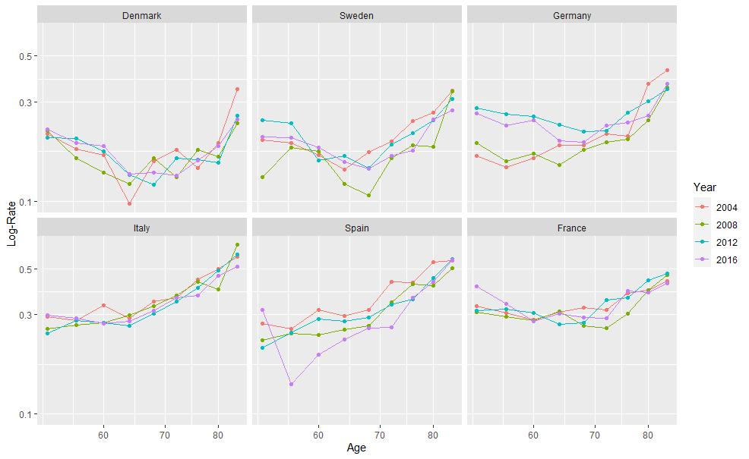

Figure 2. Period variation of Depression Log-Rates by age and selected countries

(**author´s calculations based on SHARE-ERIC**).

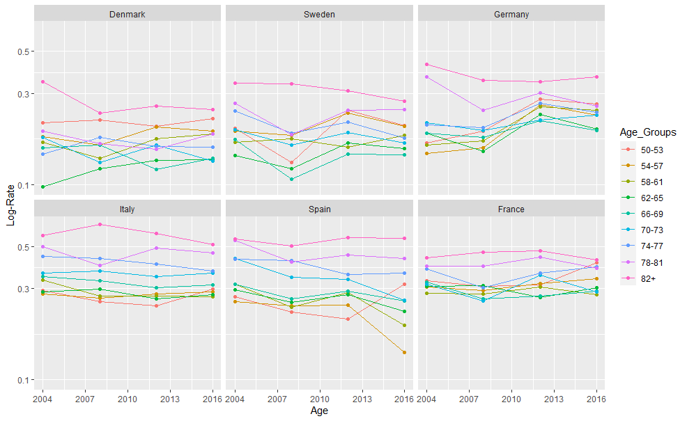

Figure 3. Period variation of Depression Log-Rates by age and selected countries

(**author´s calculations based on SHARE-ERIC**)

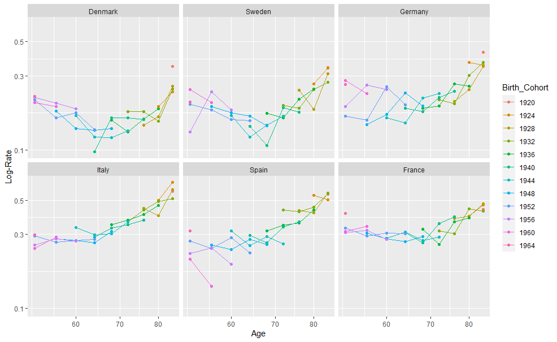

Figure 4. Age Variation of Depression Log-Rates by birth cohorts in selected countries.

(**author´s calculations based on SHARE-ERIC**).

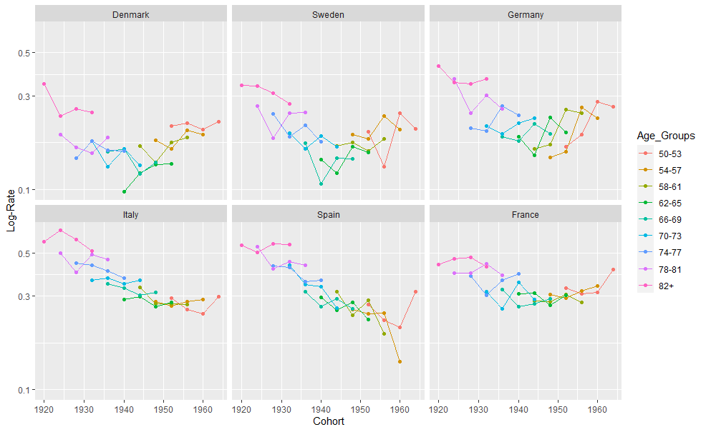

Figure 5. Cohort Variation of Depression Log-Rates by birth cohort in selected countries.

(**author´s calculations based on SHARE-ERIC**).

However, apart from visual inspection, it would be convenient to perform and Analysis of Variance (ANOVA) in order to analyze the model deviance in each case, considering that lower deviance should be better. Table 1 presents the values of the different models. We present five possible alternatives: Age, Age-Drift (which includes the linear trend) and Age-Cohort, Age-Period and Age-Period-Cohort, which include both linear and non-linear effects. While the presence of a linear trend may be negligible in some cases (as is the case for Denmark or Sweden) it is not for others (Spain, Germany, Italy, and in a lesser term, France). Furthermore, in all cases APC models tend to perform better than their two-factor counterparts (and also age-cohort models seem to have less deviance than age-period models, and this is independent of the chosen parameterization).

|  |  |  |  |  |
| --- | --- | --- | --- | --- |
| Country | Model | Model Deviance | Test Deviance | P-Value |
| Denmark | Age | 13085.2 | NA | NA |
| Age-Drift | 13085.2 | 0.02 | <0.001 |
| Age-Cohort | 11656.6 | 1428.6 | <0.001 |
| Age-Period | 12840.3 | 1383.9 | <0.001 |
| Age-Period-Cohort | 11456.3 | 200.2 | <0.001 |
| Sweden | Age | 29186.5 | NA | NA |
| Age-Drift | 29184.2 | 0.12 | <0.001 |
| Age-Cohort | 24910.4 | 4273.7 | <0.001 |
| Age-Period | 29157.4 | 4334.4 | <0.001 |
| Age-Period-Cohort | 24822.9 | 87.5 | <0.001 |
| Germany | Age | 507227.8 | NA | NA |
| Age-Drift | 403686.6 | 103541.2 | <0.001 |
| Age-Cohort | 284655.0 | 119031.6 | <0.001 |
| Age-Period | 362135.6 | 134135.8 | <0.001 |
| Age-Period-Cohort | 227999.8 | 56655.2 | <0.001 |
| Italy | Age | 98421.2 | NA | NA |
| Age-Drift | 82143.1 | 16278.12 | <0.001 |
| Age-Cohort | 79791.7 | 2351.3 | <0.001 |
| Age-Period | 80432.6 | 2151.6 | <0.001 |
| Age-Period-Cohort | 78281.0 | 1510.7 | <0.001 |
| Spain | Age | 255430.1 | NA | NA |
| Age-Drift | 171624.3 | 83805.8 | <0.001 |
| Age-Cohort | 153612.2 | 18012.1 | <0.001 |
| Age-Period | 169720.4 | 17453.2 | <0.001 |
| Age-Period-Cohort | 152267.2 | 1345.1 | <0.001 |
| France | Age | 118548.9 | NA | NA |
| Age-Drift | 114460.5 | 4088.5 | <0.001 |
| Age-Cohort | 104994.4 | 9466.1 | <0.001 |
| Age-Period | 113509.2 | 9093.3 | <0.001 |
| Age-Period-Cohort | 104416.0 | 578.4 | <0.001 |

Table 1. Analysis of variance for one factor, two factor and three factor models for selected countries**.** (**author´s calculations based on SHARE-ERIC**).

Age, Period and Cohort effects:

Figure 6 describes is the overall APC effects in the selected countries. The general non-linear age pattern (all age effects are interpretable as longitudinal trajectories of the reference cohort) reveals a similar J-shaped fashion, with moderate valleys improvements in the prevalence rates between the ages 60 and 70 before increasing sharply, except for Germany, where the increase is almost unimpeded, and Italy, where concavity is not apparent. Cohort trends are consistent with the previous three figures and indicate a firm improvement in the relative risk for Spain, a much more modest improvement for Italy, a steep increase for Germany and a slight increase in the relative risk for the and youngest French, Danish and Swedish cohorts when compared to the reference but no clear indication that those trends will continue. In terms of Period effects, we can identify a spike in relative risk for Germany during the 2012 period respectively; while the remaining countries show almost no variation, as expected (a theoretical alternative for those effects is presented in the appendix, with a period-major parameterization centered in 2012. Figure 1A is mostly opposite of Figure 6 in terms of cohort and period effects).

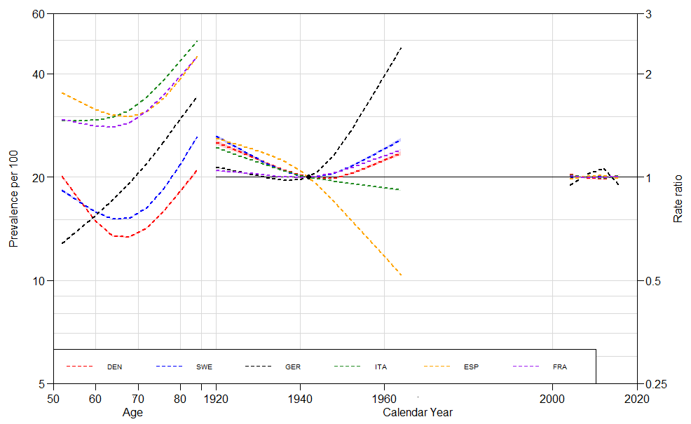

Figure 6. APC effects of Depression Prevalence in selected European countries

(**author´s calculations based on SHARE-ERIC**).

APC effects by Sex:

Figure 7 illustrates the estimated effects of the three dimensions for males in the selected countries. As with the previous figure, we can identify the curved pattern for Sweden, Denmark and Spain (albeit with highest rates at every single age group) in the age trajectory for the reference cohort, with the lowest rates registered nearing ages 60 and 70 depending on the country. Italy and France, again, do not present any visible convexities, and Germany shows a strong increase by age but also by cohort trend. In Spain, Denmark and Italy, we have opposite trends, particularly in the former, with a very sharp decrease in the relative risk for the cohorts born after 1942 and afterwards, and moderate improvement for the other two countries. Cohort trends for France and Sweden suggest an increase on the relative risk of depression for cohorts born after 1942. In regard to period effects, we may identify again an increase in the relative risk for Germany in the 2012 period, and a very slight decline for Italy during the same time.

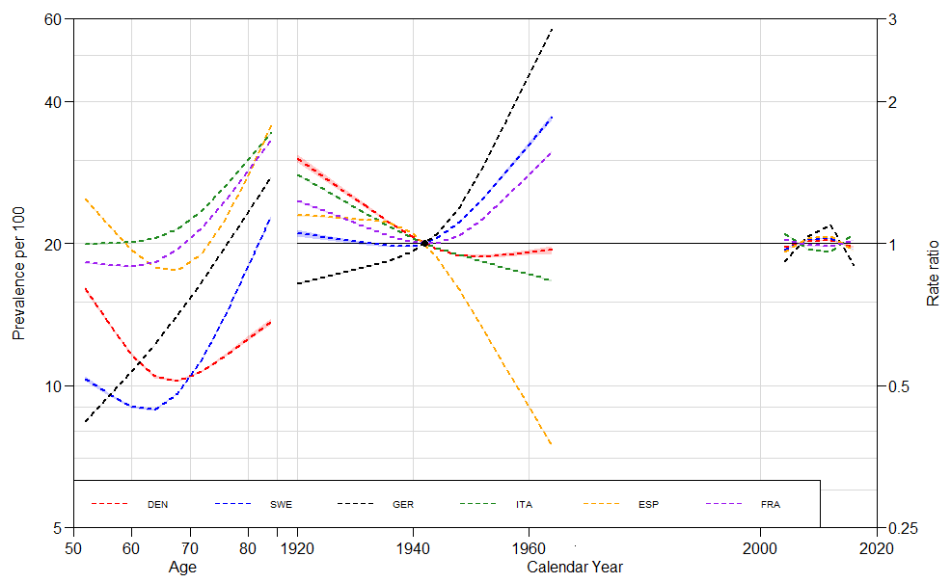

Figure 7. APC effects in Depression Prevalence in Selected Countries, Males

(**author´s calculations based on SHARE-ERIC**)

Figure 8 presents the APC effects decomposition for females in the selected countries. Age effects behave in a somewhat similar fashion when compared to their male counterparts, but with higher prevalence rates (and apparently a larger gap between the countries with lower and higher prevalence rates). The shape of the age effects seems a bit more U-shaped than J-shaped, which indicates that, unlike males, rates at the youngest and oldest age groups are not very different. It has to be noted that, also unlike males, where Italy leads rates at all age groups, here Spain, France and Italy curves seem to cross, with Italy overtaking those two countries near age 65.

For Spanish female cohorts, just like their male counterparts, we can find a sustained improvement in trends sustained over time. The opposite can be said for the youngest Danish and German cohorts: they present a higher relative risk when compared to the reference cohort. For Italian and French female cohorts, we are not able to identify the presence of a trend over time. A similar conclusion can be obtained for Swedish females after the reference cohort, although it has to be mentioned that birth cohorts born before 1942 had a higher relative risk. In a consistent fashion with the previous graphics, period effects indicate a slight spike in relative risks for German females in 2012, and the opposite for Denmark.

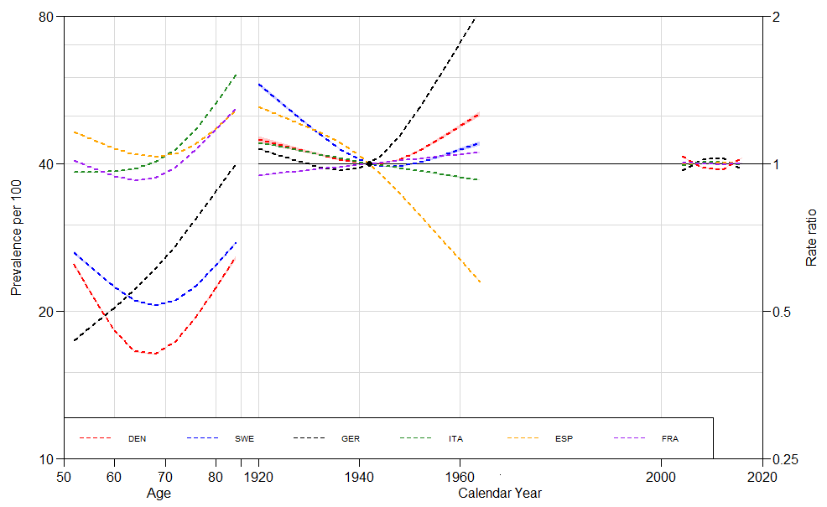

Figure 8. APC effects in Depression Prevalence in Selected Countries, Females

(**author´s calculations based on SHARE-ERIC**)

Figure 9 provides the Female/Male ratio of the three effects for the different countries. A value above 1 would indicate that the effect for females is higher than the effect for males, and vice versa. The ratio is not indicative of any improvements or decreases in overall prevalence over time, but only refers to the different ratio of effects by sex present in a particular dimension. Moreover, some large ratio differentials may refer to rather small magnitudes, so we have to be careful about interpretations. That being said, visualizing the sex ratio on the different effects is a simple and rather useful way to analyze how the dynamics of the dimensions vary by sex over time.

The majority of age trends for the reference cohort indicate a similar pattern: sex differences in prevalence seem to be larger in the age groups nearing age 50 (with female values doubling or almost doubling their male counterparts), and lower at the oldest ages, with Denmark being the only clear exception, pattern-wise. It has to be noticed that for Spain there seems to be a concavity between ages 60 and 70, where the sex gap tends to enlarge.

In regard to cohort trends, the female/male ratio is indicative of very different situations across countries. It also has to be mentioned that changes in sex ratio of cohort effects do not indicate that depression prevalence by sex is actually reversed, but is indicative of how different cohort effects affect more one chosen category when compared to another. However, if such trend is sustained in the long run, it is possible that it may lead to convergence of rates by sex at some point in the future. Sweden, France and Germany present a continuous decreasing pattern, reducing inequalities by sex as individuals age. Trends in Denmark, the country with the lowest prevalence suggests a slight increase in the ratio between females and males. And sex ratio variations in Italy, the country with the highest prevalence rates, tend to be very stable across age groups, only showing a slight decrease.

But it also has to be said that while the ratio is similar in those countries, the prevalence trend by sex is different: while in Italy there were male improvements, in Denmark an increase in female depression prevalence is responsible for the pattern. Spain and France seem to have complementary patterns, with a strong cohort trend in sex ratios after the reference cohort, when there is a steep increase in the former and a decline in the latter. As we mentioned, this does not necessarily mean an increase in the relative risk of depression prevalence for females per se. If we check the previous figures, they indicate that improvements in Spain were more pronounced for males than for females, giving the sex-ratio plot the curvature that is present in the figure. In France, however, while improvements in cohort trends for female were non-existent, depression prevalence for males increased, hence the pattern.

It is not easy to establish any remarkable conclusion regarding the sex ratio of the detrended period effects from the figure (particularly considering that they are constrained to be zero on average), but a detailed inspection indicates that in the peak of the crisis years (2011) Italian females were contextually more affected than males, while the opposite happened in Spain, Germany, Denmark and Sweden for the same period, while France remained unchanged.

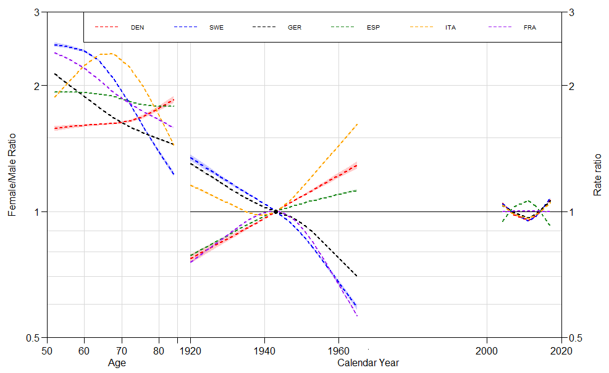

Figure 9. Sex Ratio of APC effects in Depression Prevalence in Selected Countries (**author´s calculations based on SHARE-ERIC**).

**Discussion**

Conclusions:

This study has shown the trajectories of prevalence of late-life depression by age, period and cohort effects for the 2004-2016 period for six European countries divided by sex. By visualizing Standardized Rates of depression prevalence, we can identify that depression prevalence affects between 30 and 70 per cent of the population aged 50 and above across different moments. The majority of rates in the selected countries tend to decline over time, and particularly in Spain, where the declining trend is stronger, and in Germany, where it shows a steep increase. The declining trends are obviously good news, especially when we consider that depression is expected to be a leading disability-cause worldwide. However, the lack of a strong improving trend may be problematic in the future due to population aging: even if rates remain steady or there is a slight improvement across time, population aged 50 and above will represent larger and larger proportions of the overall populations across countries, and more people could be affected by the condition.

The different age trajectories of late-life depression are relatively similar across countries for the reference cohort, with the intensity in rates across groups being the main differential. Furthermore, non-linear age trajectories of depression prevalence in general indicate a J-shaped pattern across countries, with a slight convexity (where depression prevalence decline) between ages 60 and 70 for the individuals. In some cases, like Italy or Germany, there does not seem to be an improvement for such ages, but an exponential curve pattern instead. All of those non-linear effects are second order effects, and thus, are identifiable; in opposition to linear effects. Decrease in depression prevalence between such ages is consistent with previous literature that indicates that retirement is beneficial for mental health (Fernández-Niño et al., 2018, Oksanen et al., 2011). However the figures do not tell us anything about the transition to retirement of the analyzed population, so any indications that retirement is causing the valleys may be speculative.

The Cohort effects introduce new perspective on the dynamics of depression prevalence. In Spain, improvement was present in younger cohorts for all scenarios, but with uneven intensity by sex. In Germany, the opposite situation was seen: a continuous declining mental health trend, more pronounced for males than for females. However, parts of such results are a direct consequence of assuming that the linear trend belongs to the cohort dimension. In Italy and Denmark the overall cohort trend shows modest improvement over time, and in France and Sweden there is a very subtle V-shape, centered in the reference cohort of 1943 who presents the lowest depression rate-ratios.

Introducing cohort components to analyze trends of late-life depression may not seem particularly useful to describe a phenomenon that seems to be relatively stable over time. However, it allowed us to visualize a set of heterogeneities that may not be as evident in the overall cohort trend. For instance: where is the change of rates over time and which group is driving it. In terms of Period effects, the increase of relative risks on depression was rather small but persistent in 2012, considered a European crisis year, and affected mostly Germany. That being said, we have to keep in mind again that the effects shown were a result of the chosen, theory based parameterization that arbitrarily assumed no linear trends on the period dimension.

Possible Limitations:

This study is not exempt of limitations, though. Mental health is a dynamic concept (Bell, 2014). While Depression could be chronic and a permanent feature in the life of an individual, sometimes it may be only temporary as well. Moreover, the EURO-D scale, in spite of being validated and its performance was deemed as satisfactory, has the same limitations that most scales have: they have to rely on the honesty and the accuracy of the respondent, and they cannot foresee sudden abrupt mood changes from wave to wave that could alter an expected result of a questionnaire. Also, there is the question of coverage: while some authors pointed out that there is an East-West gap in late life depression prevalence (Hansen, Slagsvold and Veenstra, 2017), since no eastern countries took part in all of the waves of SHARE we only focus in the countries chosen for the analysis. Furthermore, as we mentioned, other potentially interesting variables, such as partnership status and educational attainment, were removed due to issues with the sample size and composition.

There are also limitations involving APC modeling that were mentioned previously. Since there is no unique theoretical mathematical solution for the linear identification problem yet, the suggested approach mathematically is incapable of discerning a solution for the linear identification problem. And while the chosen approach, based on theory, offers a possible solution, such solution is the result of the particular constraints chosen for this case (Yang and Land, 2013). Finally, we have to mention that due to sample size limitations, a small group of age-period squares were imputated; hence, while unlikely, estimates may be slightly biased in such sense.

Final Comments:

This is a very simple study that just by describing trends of a particular health issue can delve into many existing lines of research, ranging from causal effects between retirement and health benefits to cohort trends across different countries of other diseases of the mind (or joint diseases, since depression is usually associated with joint morbidities), among many others. In the light of the Covid-19 pandemic, it can also introduce the question if there could be such thing as a continuous period trend in the future in regards to mental health and depression. Furthermore, by showing repeated measurements with the same data source and offering a decomposition of the age trajectories of late-life depression, along with cohort and period effects, it provided a benchmark for further studies across countries.

While in this study we do not find evidence that suggests that depression prevalence rates are increasing over time for the overall population, it is still a major health problem in the world that we live in, particularly considering that populations across Europe are in a continuous aging process. Hence, this discussion about mental health inequalities and current social structures should not be avoided in the future.

**Bibliographic References:**

Acosta. E, van Raalte, A. (2019) “APC curvature plots: Displaying nonlinear age-period-cohort patterns on Lexis plots” *Demographic Research.* 41(42) p 1205-1234 https://doi.org/ [10.4054/DemRes.2019.41.42](https://dx.doi.org/10.4054/DemRes.2019.41.42)

Aichberger, M. C., Schouler-Ocak, M., Mundt, A., Busch, M. A., Nickels, E., Heimann, H. M., Ströhle, A., Reischies, F. M., Heinz, A., & Rapp, M. A. (2010). Depression in middle-aged and older first generation migrants in Europe: results from the Survey of Health, Ageing and Retirement in Europe (SHARE). *European psychiatry : the journal of the Association of European Psychiatrists*, *25*(8), 468–475. https://doi.org/10.1016/j.eurpsy.2009.11.009

Aziz, R., Steffens, D. C. (2013). What are the causes of late-life depression? *The Psychiatric clinics of North America*, *36*(4), 497–516. https://doi.org/10.1016/j.psc.2013.08.001

Bell, A. (2014) A multiLife-course and cohort trajectories of mental health in the UK, 1991–2008 – A multilevel age–period–cohort analysis. Social Science and Medicine vol 120, pp 21-30. <https://doi.org/10.1016/j.socscimed.2014.09.008>

Bergmann, M. Kneip, T., De Luca, G., Scherpenzeel, A. (2019). Survey participation in the Survey of Health, Ageing and Retirement in Europe (SHARE), Wave 1-7. Based on Release 7.0.0. SHARE Working Paper Series 41-2019. Munich: SHARE-ERIC.

Blazer, D.G. (2005) [Depression and social support in late life: A clear but not obvious relationship](https://www.tandfonline.com/doi/abs/10.1080/13607860500294266). *Aging and Mental Health* 9:6, pages 497-499. https://doi.org/full/10.1080/13607860500294266

Börsch-Supan, A. (2019). Survey of Health, Ageing and Retirement in Europe (SHARE) Waves 1 to 7. Release version: 7.0.0. SHARE-ERIC. Data set. https://doi.org/ 10.6103/SHARE.w7.700

Carstensen, B. (2007). Age-period-cohort models for the Lexis diagram. Statistics in Medicine, 26(15), 3018–3045. <https://doi.org/10.1002/sim.2764>

Carstensen B., Plummer, M., Laara, E., Hills, M. (2019). Epi: A Package for Statistical Analysis in Epidemiology. R package version 2.40, [https://CRAN.R-project.org/package=Epi](https://cran.r-project.org/package=Epi).

Colman, I., Ataullahjan, A. (2010) Life course perspectives on the epidemiology of depression. [Canadian Journal of Psychiatry.](https://www.ncbi.nlm.nih.gov/pubmed/20964941) 2010 Oct;55(10):622-32.

https://doi.org/ [10.1177/070674371005501002](https://doi.org/10.1177/070674371005501002)

Cuadros, D.F., Tomita, A., Vandormael, A. et al. (2019) Spatial structure of depression in South Africa: A longitudinal panel survey of a nationally representative sample of households. Scientific Reports 9, 979 on the epidemiology of depression. https://doi.org/ [10.1038/s41598-018-37791-1](https://doi.org/10.1177/070674371005501002)

Dewey, M., Prince, M. (2005) Mental health. In Börsch-Supan, A, Brugiavini, A, Jürges, H, Mackenbach, J, Siegrist, J and Weber, G (eds), Health, Ageing and Retirement in Europe – First Results from the Survey of Health, Ageing and Retirement in Europe. Mannheim, Germany: Mannheim Research Institute for the Economics of Aging (MEA), pp. 108–117

Dobson, A., Hockey, R., Chan, H., Mishra, G. (2020)*.* Flexible age-period-cohort modelling illustrated using obesity prevalence data. *BMC Medical Research Methodology* 20,16. <https://doi.org/10.1186/s12874-020-0904-8>

Fernández-Niño, J.A, Bonilla-Tinoco, L.J, Manrique-Espinoza, B.S, Romero-Martínez, M., Sosa-Ortiz, A.L. (2018). Work status, retirement, and depression in older adults: An analysis of six countries based on the Study on Global Ageing and Adult Health (SAGE),

*SSM - Population Health* (6), 1-8 https://doi.org/10.1016/j.ssmph.2018.07.008.

Ferrari, A.J, Charlson, F.J, Norman, R.E., Patten, S.B., Freedman, G., Murray, C.J.L., Whiteford, H.A (2013). Burden of Depressive Disorders by Country, Sex, Age and Year: Findings from the Global Burden of Disease study 2010. PLOS Medicine, 10(11).

Fiske, A., Wetherell, J. L., Gatz, M. (2009). Depression in older adults. *Annual review of clinical psychology*, *5*, 363–389. https://doi.org/10.1146/annurev.clinpsy.032408.153621

Frasquilho, D., Matos, M. G., Salonna, F., Guerreiro, D., Storti, C. C., Gaspar, T., & Caldas-de-Almeida, J. M. (2016). Mental health outcomes in times of economic recession: a systematic literature review. *BMC public health*, *16*, 115. <https://doi.org/10.1186/s12889-016-2720-y>

Fryers, T., Melzer, D., & Jenkins, R. (2003). Social inequalities and the common mental disorders: a systematic review of the evidence. *Social psychiatry and psychiatric epidemiology*, *38*(5), 229–237. https://doi.org/10.1007/s00127-003-0627-2

Gennaro, C., Paccagnella, O., Zaninotto, P. (2019). A model-driven approach to better identify older people at risk of depression. *Ageing and Society,* 1-23. https://doi.org/10.1017/S0144686X19001077

Glenn, N. (2005) *Cohort Analysis, Second Edition.* Series: Quantitative Applications in the Social Sciences. SAGE publications.

Guerra, M., Ferri, C., Llibre-Rodriguez, J., Prina, M., Prince, M. (2015). Psychometric properties of EURO-D, a geriatric depression scale: A cross-cultural validation study. BMC psychiatry. 15.12.10. Https://doi.org/10.1186/s12888-015-0390-4.

Hansen, T., Slagsvold, B., Veenstra, M. (2017). Educational inequalities in late-life depression across Europe: results from the generations and gender survey. *European journal of ageing*, *14*(4), 407–418. https://doi.org/10.1007/s10433-017-0421-8

Hobcraft, J., Menken, J., and Preston, S. (1982). Age, Period, and Cohort Effects in Demography: A Review. Population Index, 48(1), 4–43. <https://doi.org/10.2307/2736356>

Holford, T.R. (1992) Analysing the temporal effects of age, period and cohort. Statistical Methods in Medical Research;1(3):317–37. <https://doi.org/10.1177/096228029200100306>.

Horackova, K., Kopecek, M., Machů, V., Kagstrom, A., Aarsland, D., Motlova, L., Cermakova, P. (2019). Prevalence of late-life depression and gap in mental health service use across European regions. *European Psychiatry,* *57*, 19-25. https://doi.org/10.1016/j.eurpsy.2018.12.002

Lavori P.W., Klerman G.L., Keller M.B., et al. (1987) Age-period-cohort analysis of secular trends in onset of major depression: findings in siblings of patients with major affective disorder. *J Psychiatr Res*;21(1):23–35.

Marmot, M. (2005) “Social determinants of health inequalities” *The Lancet* No. 365: 1099-1104

Kessler R, Berglund P, Demler O, Jin R, Koretz D, Merikangas K, Rush J, Walters E, Wang P. (2003) The epidemiology of major depressive disorder: results from the National Comorbidity Survey Replication (NCS-R) Journal of the American Medical Association.

Keyes, K. M., Nicholson, R., Kinley, J., Raposo, S., Stein, M. B., Goldner, E. M., & Sareen, J. (2014). Age, period, and cohort effects in psychological distress in the United States and Canada. *American journal of epidemiology*, *179*(10), 1216–1227. <https://doi.org/10.1093/aje/kwu029>

Nielsen, B., Nielsen, J.P. (2014). Identification and forecasting in mortality models. Scientific World Journal, Article ID 347043.

Oksanen, T., Vahtera, J., Westerlund, H., Pentti, J., Sjösten, N., Virtanen, M., Kawachi, I., & Kivimäki, M. (2011). Is retirement beneficial for mental health?: antidepressant use before and after retirement. *Epidemiology (Cambridge, Mass.)*, *22*(4), 553–559. https://doi.org/10.1097/EDE.0b013e31821c41bd

Pascual-Sáez, M., Cantarero-Prieto, D. & Blázquez-Fernández, C. Partner’s depression and quality of life among older Europeans. *Eur J Health Econ* 20, 1093–1101 (2019). <https://doi.org/10.1007/s10198-019-01081-y>

Prince, M., F. Reischies, A. T. F. Beekman, R. Fuhrer, C. Jonker, S.-L. Kivelä, B. Lawlor, A. Lobo, H. Magnússon, I. Fichter, H. van Oyen, M. Roelands, I. Skoog, C. Turrina, J. R, Copeland, M. (1999). Development of the EURO-D scale – a European Union initiative to compare symptoms of depression in 14 European centres. British Journal of Psychiatry 174:330-38.

Rau R., Bohk-Ewald C., Muszyńska M.M., Vaupel J.W. (2018) *The Lexis Diagram. In: Visualizing Mortality Dynamics in the Lexis Diagram.* The Springer Series on Demographic Methods and Population Analysis, vol 44. Springer, Cham

Riumallo-Herl, C., Basu, S., Stuckler, D., Courtin, E., Avendano, M. (2014). Job loss, wealth and depression during the Great Recession in the USA and Europe. *International journal of epidemiology*, *43*(5), 1508–1517. https://doi.org/10.1093/ije/dyu048

Ryder, N. B. (1965). The Cohort as a Concept in the Study of Social Change. American *Sociological Review*, 30(6), 843–861. https://doi.org/ 10.2307/2090964

Spiers, N., Bebbington, P., McManus, S., Brugha, T. S., Jenkins, R., & Meltzer, H. (2011). Age and birth cohort differences in the prevalence of common mental disorder in England: National Psychiatric Morbidity Surveys 1993-2007. *The British journal of psychiatry : the journal of mental science*, *198*(6), 479–484. https://doi.org/10.1192/bjp.bp.110.084269

Thomson, R.M., Niedzwiedz, C.L., Katikireddi S.V. (2018) Trends in gender and socioeconomic inequalities in mental health following the Great Recession and subsequent austerity policies: a repeat cross-sectional analysis of the Health Surveys for England *BMJ Open*2018;**8:**e022924. https://doi.org/ 10.1136/bmjopen-2018-022924

Van de Velde S., Bracke, P., Levecque K. (2010), Gender differences in depression in 23 European countries. Cross-national variation in the gender gap in depression,

Social Science and Medicine, Volume 71, Issue 2, 2010, Pages 305-313, ISSN 0277-536,

<https://doi.org/10.1016/j.socscimed.2010.03.035>.

World Health Organization (2008) Closing the gap in a generation: health equity through action and the social determinants of health. WHO, Geneva

Wickham, H. (2016). ggplot2: Elegant Graphics for Data Analysis. Springer-Verlag New York. ISBN 978-3-319-24277-4, [https://ggplot2.tidyverse.org](https://ggplot2.tidyverse.org/).

Wickramaratne P.J., Weissman M.M., Leaf P.J., et al. (1989) Age, period and cohort effects on the risk of major depression: results from five United States communities. *J Clin Epidemiol*. 42(4):333–343

Yang, Y., Land, K. C. (2013). *Age-Period-Cohort Analysis: New Models, Methods, and Empirical Applications*. CRC Press

Zhao K.X., Huang C.Q., Xiao Q., Gao Y., Liu Q.X., Wang Z.R., Xie Y.Z. (2012) Age and risk for depression among the elderly: a meta-analysis of the published literature. CNS Spectr 17:142–15

Appendix:

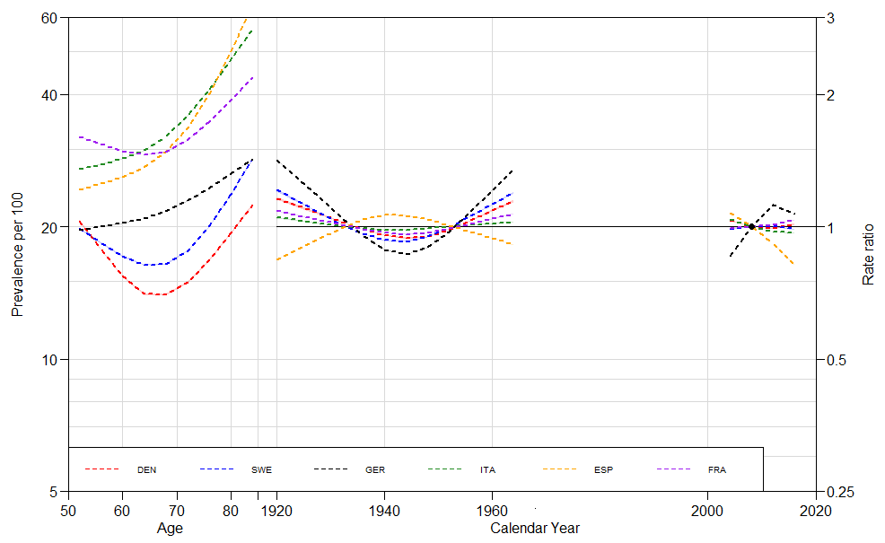

Figure 1A. APC effects in a Period-Major Parameterization centered in Year 2008.